**Documentation of Automation Software used**

**Software and tools:**

* Eclipse IDE - Oxygen
* JDK 1.8
* Selenium WebDriver 3.7.1
* Browser related driver executables

Version 0.19 for firefox browser with version 56.0

Version 80.0.3987.106 for firefox browser with version 80.0

* Maven
* Github Desktop 2.3.1

**Creating Maven Project:**

* Go to File menu in Eclipse and select project and in the wizard select Maven project as shown below

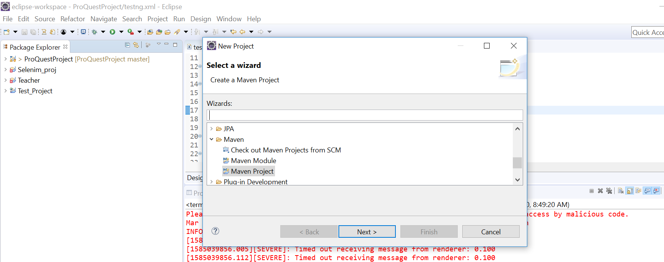

* Click Next -- Next -- and in Group Id and Artifact Id give project name as below:

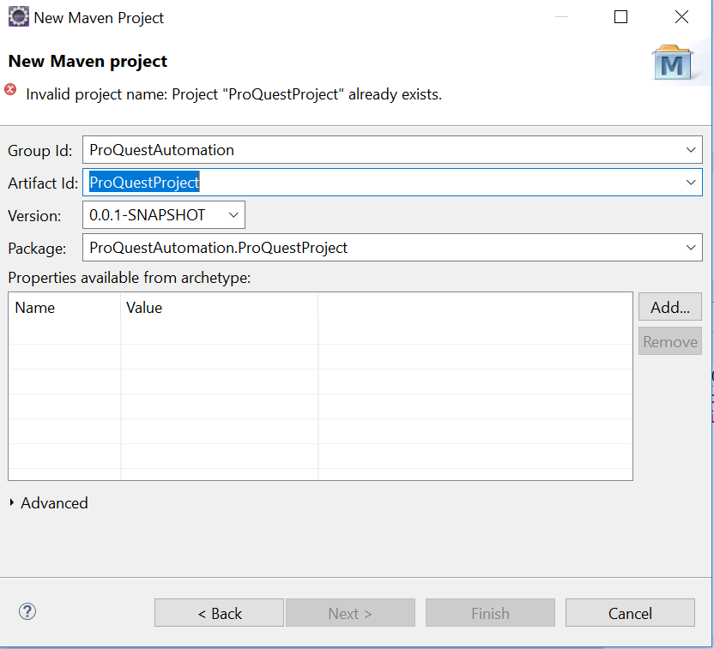

* Click Finish. It creates a Maven project and inside the project it creates a pom.xml file.
* Go to pom.xml tab add dependency related information from below url

<http://www.mvnrepository.com>

* Search Selenium Server and click on 3.7.1 link. Copy the dependency information from here and add it in the pom.xml file. Similarly, add TestNG(version 6.11), Apache POI(version 3.17), log4j(version 1.2.17), etc. Now save the project -- control+S -- in order to build the dependency jar files to the project. As a result, Maven dependency file is created as shown below.

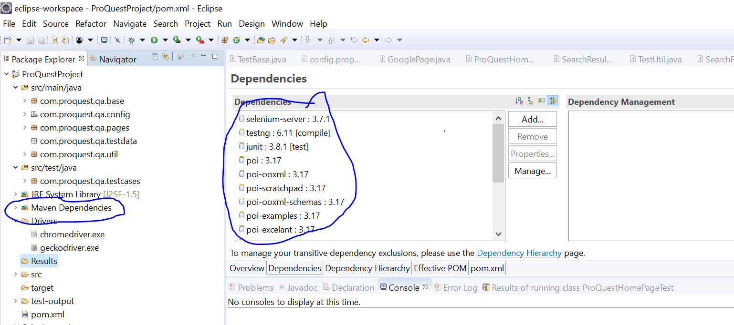

* For log4j create a source folder (./src/main/resources) and create a properties file inside this folder. This file contains the set level and file, console and debug appenders.

**Eclipse and JDK Installation:**

**JDK installation steps:**

1. Go to this URL: <https://www.oracle.com/technetwork/java/javase/downloads/jdk8-downloads-2133151.html>

2. Select radio button -- Accept Licence Agreement

3. You can see the file downloaded in download folder.

4. Double click on the .exe file and click on Next, next till finish.

5. Verify that JDK is installed successfully in the below location

C:\Program Files\Java\jdk1.8.0_144\bin

OR

Open command Prompt and hit this command.

Java –version

**Eclipse Installation:**

* Download Eclipse Editor and to launch it, set the jdk path in system environment variable.
* Right click on Computer -- click on Properties -- click on Advanced System Settings -- Under Advanced Tab (this tab is selected by default), click on Environmental Variables -- Under System variable section, select path (Variable name) and click on EDIT
* In Variable Value textbox, go to the end, add a semicolon and copy and paste this path: C:\Program Files\Java\jdk1.8.0_144\bin

**Selenium WebDriver and driver executables:**

1. Launch eclipse and go to package explorer [navigation path :- Window menu → Show View → Package Explorer]
2. Create a java project [File → New→ Java Project]
3. Selenium in order to communicate with browser it needs some extra file known as **driver executables**, we download this. Then right click on Java Project and add a new folder with name “Drivers” [File → New→ Folder]
4. Copy **driver executable files** from the system and paste it into this Drivers folder.
5. In the next step download and integrate Selenium. Selenium is an open source web automation tool that comes in the form of **.jar file**, we download this and follow the steps below to attach it to the build path.
6. right click on the project → build path → configure build path → Libraries tab → Add External jars → select the .jar file → Apply → ok

Other way of adding .jar file to java build path is: create another folder with name **“jar”** and copy **Selenium Standalone Server.jar** file into this jar folder. Expand the jar folder and right click on **Selenium Standalone Server.jar** file → select **Build Path** → select **Add to Build Path**

1. As soon as you add any .jar files to build path, a new folder will be available called **“Reference Libraries”** under the package explorer section and you can see the .jar file is added to this **“Reference Libraries”**
2. To remove the .jar file from the java build path, go to the Reference Libraries → select the .jar file → right click → select build path → Remove from build path.

That’s how we integrate or install Selenium.

1. Once the Selenium tool is integrated we have to set the system properties of the browser drivers.  That is achieved through the setProperty(key, value) method. Here setProperty() is a method of System class, which takes 2 arguments, key and value. As part of the value, we specify the path of the driver executable and as part of key, we pass predefined key set by selenium community.

Line of code is,

System.setProperty("webdriver.gecko.driver","path of geckodriver.exe")

System.setProperty("webdriver.chrome.driver","path of chromedriver.exe")

**Github Setup:**

* Go to [www.github.com](http://www.github.com)
* Register and sign in
* Now, download github desktop from the following url :

<https://desktop.github.com/>

* Now launch the github desktop.exe
* File – New Repository
* Enter project name which we want to upload under NAME text box
* And Local path is the actual workspace where in our project is located.

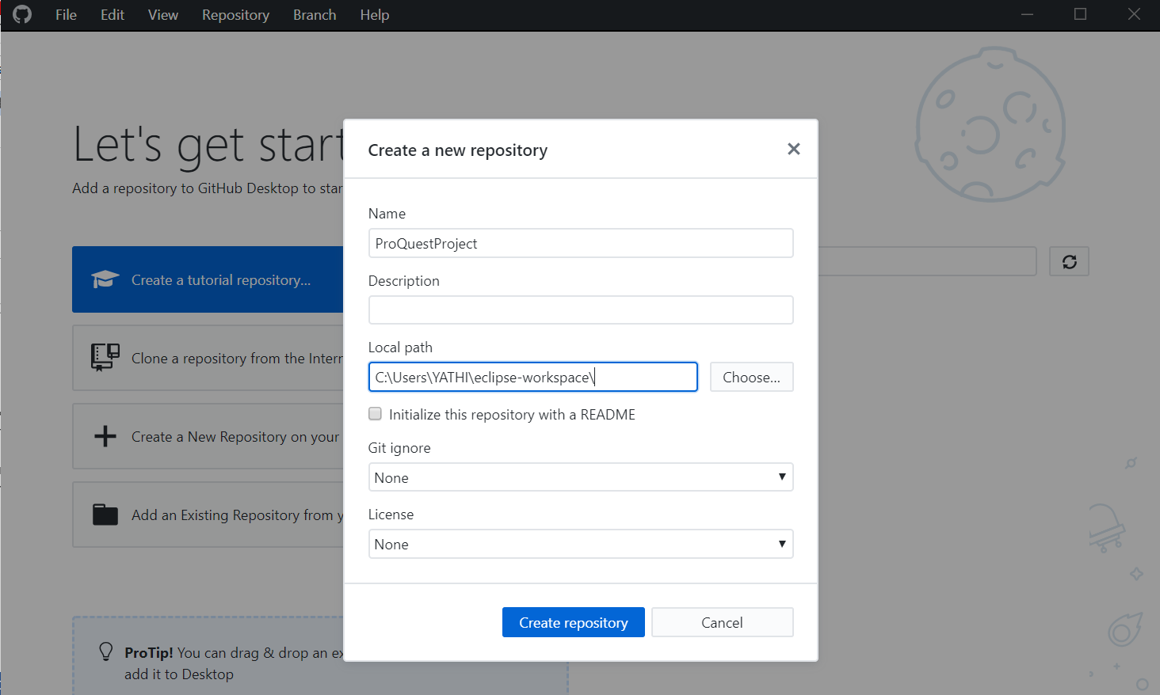

* Then click on Publish Repository
* Uncheck the option for keeping the code private and click on Publish repository

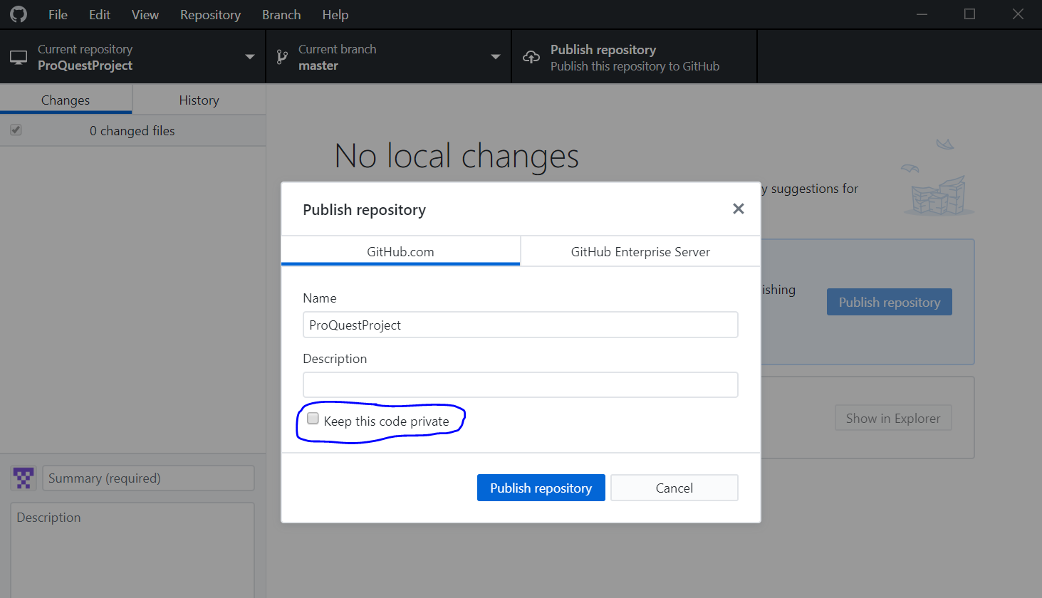

* Once it is uploaded successfully, u will get something like this as shown below.

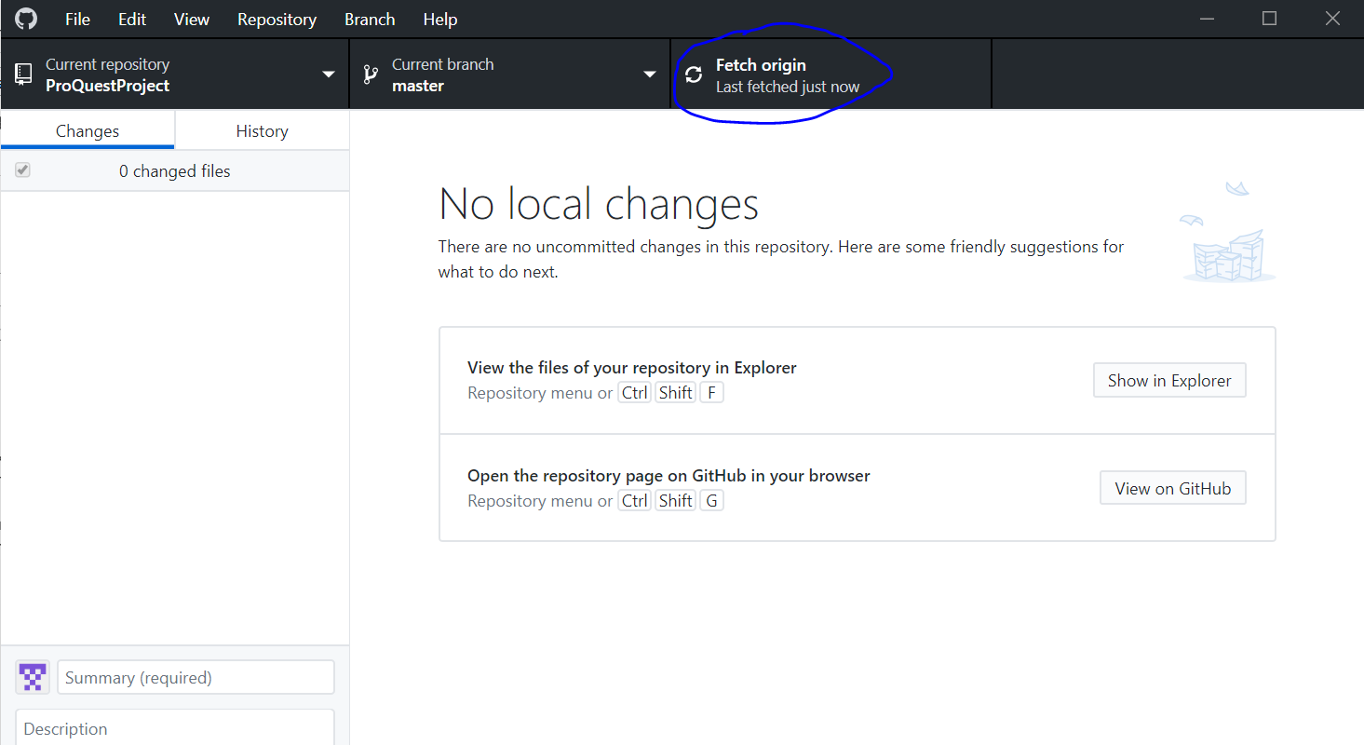

* Now, go to the github , you will see that project is successfully uploaded to the central as shown below.

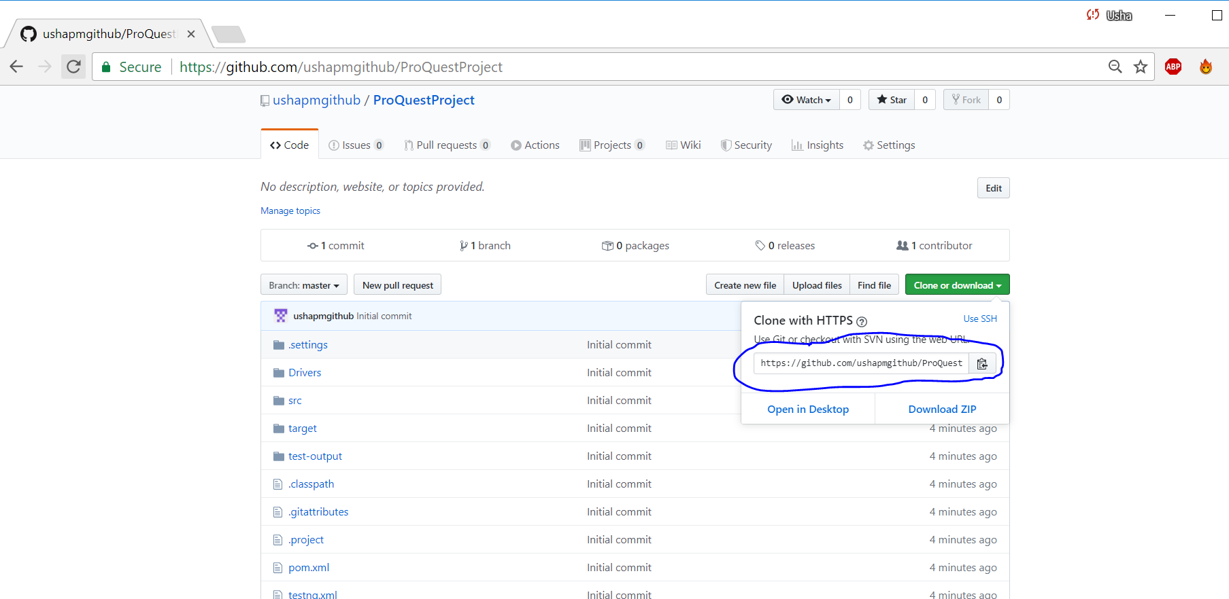

* Copy the URI above and import the project in Elcipse.

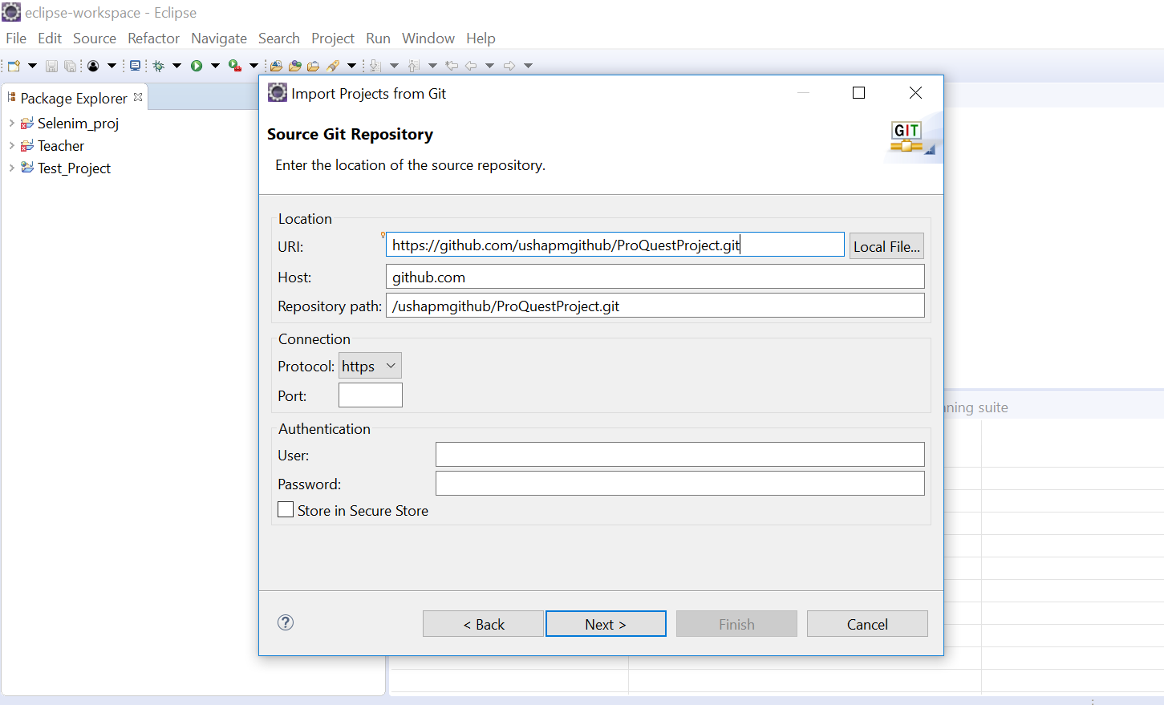

* It will start downloading the project from Github to the local system in eclipse.
* Once imported, we will do some changes and we will upload it back to github by using this navigation: Right click on the project -- TEAM -- COMMIT
* Drag and drop the changes from unstaged changes area to staged changes are. Now commit and push.
* Now checkout the latest code from Github and get it in your local system.